# Installing on Windows

Link : <https://sqlitestudio.pl/>

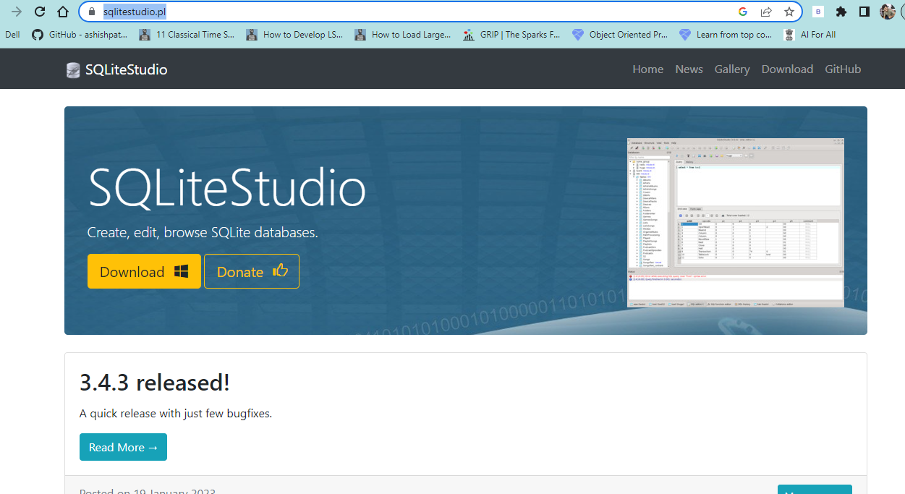

# Change Fonts

Tools > Open Configuration Dialog (F10) > Look & feel > Fonts

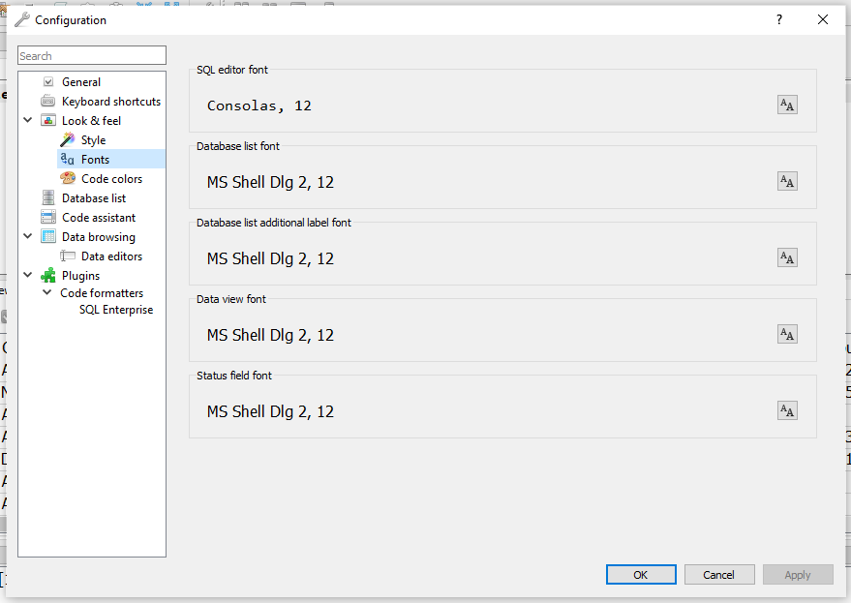

# Add Database

Database > Add a database > Select File

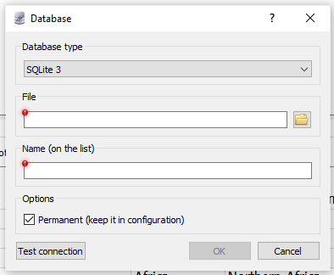

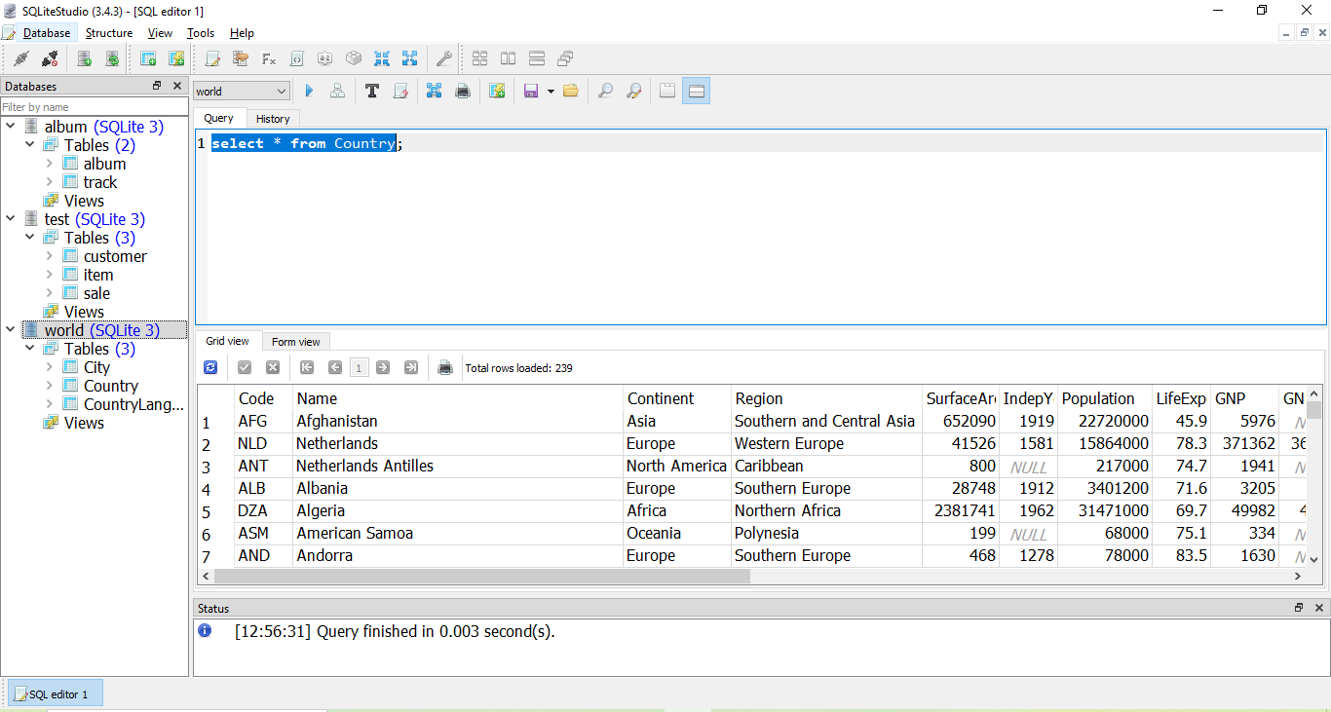

# SQL Overview

1. About SQL

* SQL Statement :

SELECT * FROM Country WHERE Continent = ‘Europe’;

/* Statement */

FROM Country

/* from clause */

WHERE Continent = ‘Europe’

/* where clause */

Continent = ‘Europe’

/* logical expression */

* CRUD

Create

Read

Update

Delete

* SELECT  
  SELECT * FROM Customer;
* INSERT  
  INSERT INTO Customer (name, city, state)   
  VALUES (‘Jimi Hendrix’, ‘Renton’, ‘WA’);
* UPDATE  
  UPDATE   
  SET   
  Address = ‘123, Music Avenue’, Zip = ‘987654’   
  WHERE id = 5;
* DELETE  
  DELETE FROM Customer WHERE id = 4;

1. Database organization

* A database has tables
* A table has rows and columns
* A row is like a record
* A column is like a field
* A unique key identifies a table row
* Tables are related by keys

1. The SELECT statement

SELECT 'Hello, World';

